**VAAC Parsing Issues**

PDC has developed a unique real time global volcano alerting capability using a combination of the real time Volcanic Ash Advisory Centers (VAAC) around the globe and the risk rating for each of the ~1,500 active volcanoes. These advisories are text bulletins from 9 different centers that are posted in NOAA’s Telecommunication Gateway: <http://tgftp.nws.noaa.gov/data/raw/fv/?C=M;O=D> . This link provides samples to advisories from all 9 centers and is updated in real time with approximately 10-20 daily updates.

We knew going in that there would be risks parsing data from bulletin texts from 9 different sources and spent some time mitigating common issues (accidental page breaks, different spellings for words, etc.), but still have ~4% rate where issues occur.

We parse the advisory data to determine the severity of the event, as well as to map the Ash Cloud position in 6-hour increments. When parsing fails we put up a “PROCESSING” message. An example of this and the associated bulletin text is below:

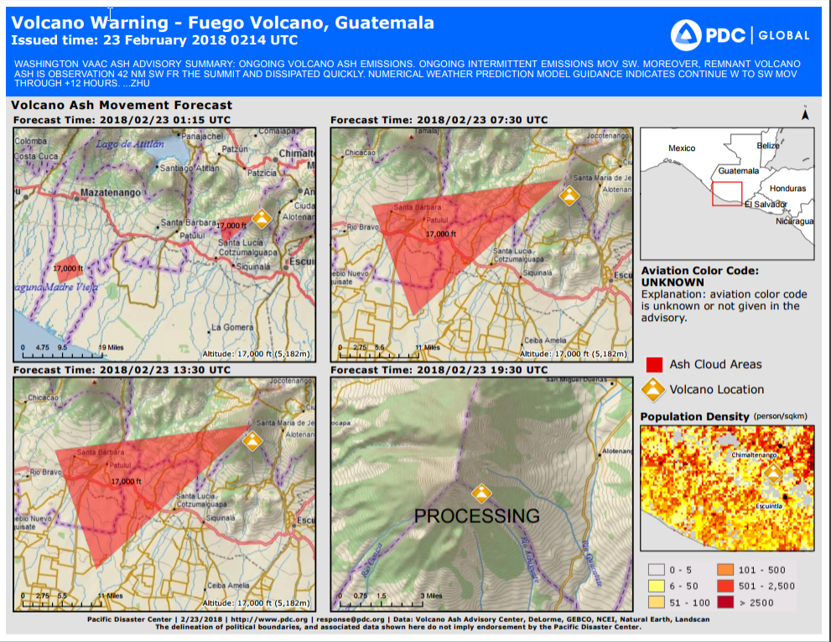

Here are 3 Bulletins that produced parsing errors:

***1)***

FVXX23 KNES 230800

VA ADVISORY

DTG: 20180223/0800Z

VAAC: WASHINGTON

VOLCANO: FUEGO 342090

PSN: N1428 W09052

AREA: GUATEMALA

SUMMIT ELEV: 12346 FT (3763 M)

ADVISORY NR: 2018/167

INFO SOURCE: GOES-EAST. NWP MODELS. CIMSS VOLCAT.

VOLCANO WEB CAMERA.

ERUPTION DETAILS: ONGOING VA EMS

OBS VA DTG: 23/0730Z

OBS VA CLD: SFC/FL170 N1430 W09055 - N1426 W09055

- N1416 W09119 - N1426 W09122 - N1430 W09055 MOV

W 10-15KT

FCST VA CLD +6HR: 23/1330Z SFC/FL170 N1430 W09055

- N1426 W09054 - N1416 W09119 - N1426 W09123 -

N1430 W09055

FCST VA CLD +12HR: 23/1930Z SFC/FL170 N1431

W09056 - N1426 W09054 - N1415 W09119 - N1426

W09122 - N1431 W09056

FCST VA CLD +18HR: 24/0130Z SFC/FL170 NO ASH EXP

RMK: INTERMITTENT VA EMS SEEN ON STLT IMAGERY MOV

WSW APPROX 25 NM AWAY FM THE SUMMIT. MODELS

SUGGEST GENERAL WESTWARD MOV THRU T+12 HRS.

...KIM

NXT ADVISORY: WILL BE ISSUED BY 20180223/1400Z

**2)**

FVXX23 KNES 230214

VA ADVISORY

DTG: 20180223/0214Z

VAAC: WASHINGTON

VOLCANO: FUEGO 342090

PSN: N1428 W09052

AREA: GUATEMALA

SUMMIT ELEV: 12346 FT (3763 M)

ADVISORY NR: 2018/166

INFO SOURCE: GOES-EAST. NWP MODELS. CIMSS VOLCAT.

ERUPTION DETAILS: ONGOING VA EMS

OBS VA DTG: 23/0115Z

OBS VA CLD: SFC/FL170 N1421 W09131 - N1417 W09129

- N1415 W09134 - N1419 W09135 - N1421 W09131 MOV

SW 10-15KT SFC/FL170 N1429 W09053 - N1429 W09053

- N1423 W09100 - N1428 W09101 - N1429 W09053 MOV

SW 10-15KT

FCST VA CLD +6HR: 23/0730Z SFC/FL170 N1430 W09053

- N1414 W09111 - N1427 W09116 - N1430 W09053

FCST VA CLD +12HR: 23/1330Z SFC/FL170 N1430

W09052 - N1413 W09111 - N1427 W09116 - N1430

W09052

FCST VA CLD +18HR: 23/1930Z SFC/FL170 NO ASH EXP

RMK: ONGOING INTERMITTENT EMS MOV SW. MOREOVER,

REMNANT VA IS OBS 42 NM SW FR THE SUMMIT AND

DISP QUICKLY. NWP MODEL GUIDANCE INDICATES CONT W

TO SW MOV THROUGH +12 HRS. ...ZHU

NXT ADVISORY: WILL BE ISSUED BY 20180223/0815Z

***3)***

FVXX23 KNES 220841

VA ADVISORY

DTG: 20180222/0841Z

VAAC: WASHINGTON

VOLCANO: FUEGO 342090

PSN: N1428 W09052

AREA: GUATEMALA

SUMMIT ELEV: 12346 FT (3763 M)

ADVISORY NR: 2018/163

INFO SOURCE: GOES-EAST. NWP MODELS. CIMSS VOLCAT.

VOLCANO WEB CAMERA.

ERUPTION DETAILS: VA EMS CONTINUE

OBS VA DTG: 22/0815Z

OBS VA CLD: SFC/FL150 N1433 W09113 - N1430 W09054

- N1426 W09055 - N1423 W09111 - N1433 W09113 MOV

W 5-10KT

FCST VA CLD +6HR: 22/1430Z SFC/FL150 N1436 W09153

- N1425 W09154 - N1424 W09213 - N1435 W09214 -

N1436 W09153 SFC/FL150 N1433 W09111 - N1430

W09055 - N1426 W09054 - N1423 W09110 - N1433

W09111

FCST VA CLD +12HR: 22/2030Z SFC/FL150 N1434

W09112 - N1430 W09053 - N1427 W09055 - N1424

W09110 - N1434 W09112

FCST VA CLD +18HR: 23/0230Z SFC/FL150 NO ASH EXP

RMK: CONT VA EM SEEN ON STLT MOV W EXTENDING

APPROX 20 NM AWAY FM THE SUMMIT. VA HEIGHT AND

MOVEMENT BASED ON GOES EAST IMAGERY. MODELS

SUGGEST W-WARD MOV THRU T+12 HRS ...KIM

NXT ADVISORY: WILL BE ISSUED BY 20180222/1445Z